**DAY 1**

**Analysis** is the process of investigating or processing data or information. **Analyst** is the person that performs the analysis; a person with a certain skillset and training or expertise in the field of the analysis.

**Business Analysis** is the process of enabling change from an organizational perspective by defining needs and recommending solutions that deliver value to stakeholders: it is the process of understanding the functional/ technical problems of organizations, defining them, and solving them.

A **Business Analyst** is the person with the required skillset to perform the analysis, that understands the business/domain and its functions, identifies obstacles and defines them by eliciting requirements from stakeholders, assesses the business model or its integration with technology, improves business process, products, services through data analysis

**DAY 2**

**Challenges in software engineering:**

* Methodology used for different projects varies, depending on the size and complexity of the project
* Changes are unavoidable; accommodating changes during software development is a major challenge
* Not fully understanding user requirements: this can result in development of software that does not meet user expectation.
* Producing high-quality software that can accommodate changes with acceptable schedules
* Informal communication that is not properly documented, documenting changes in a non-standard format
* Inadequate testing of software can affect quality of software
* Software design challenges: designing reusable software, software based on microservices
* Software implementation challenges: programmability of underlying infrastructure, flexible design of software for optimal deployment
* Software quality challenges, security challenges are to be considered during design and implementation to anticipate any security threats

**Who is a stakeholder?**

* Any individual, group or organization that is concerned with a business or organization. They may be classified as internal, or external.
  + Internal: those within organization- employees and management
  + External: those outside the organization – trade associations, government
* It is important to perform stakeholder analysis and mapping at the beginning of the project to identify the needs of stakeholders and to determine key stakeholders based on their influence, impact and interest in the business/project

**SDLC processes and methodologies:**

* Software development lifecycle (SDLC) is a framework that defines the steps involved in the development of software at each phase. It covers the detailed plan for building, deploying and maintaining the software.
* Phases of SDLC are: Requirements gathering and analysis, design, implementation and coding, testing, deployment and maintenance.

SDLC models:

Waterfall model:

* Also called linear sequential model
* Output on one phase is input to the next; only after the completion of one phase can the next begin
* Advantages are that it is a simple, easy-to-understand model, and deliverables of each phase are clearly defined
* Disadvantages are that it is a time-consuming method as phases do not occur simultaneously; it is not suitable for projects where there is uncertainty in requirements

V-shaped model:

* Also known as verification and validation model
* Verification and validation occur simultaneously i.e. development and testing occur simultaneously
* Similar to Waterfall except test planning and testing begin early
* Advantages: simple, good for smaller projects where requirements are clearly defined
* Disadvantages: not good for on-going projects; changes in requirements at later stage can result in high cost

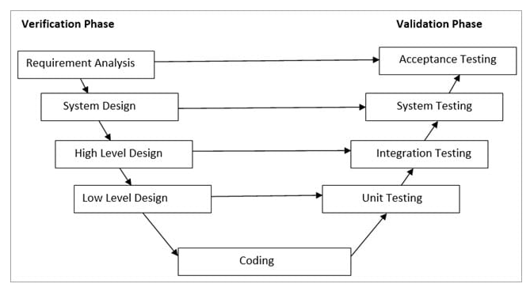

Prototype model:

* Prototype with limited capabilities and dummy functions is created before actual software; enables understanding of user needs by getting their feedback, which can be implemented into actual software
* Advantages: cuts time and cost of development as defects are found earlier; early involvement of customer ensures elimination of confusion in understanding customer requirement
* Disadvantage: early involvement of customer can result in more changes in requirements, increasing scope complexity; may affect delivery time

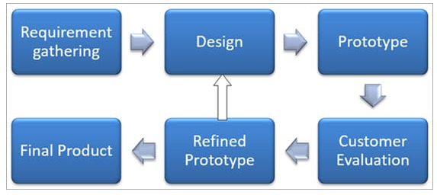

Spiral model:

* Combines iterative and prototype approaches
* Spiral model phases are followed in the iterations. The loops in the model represent the phase of the SDLC process i.e. the innermost loop is of requirement gathering & analysis which follows the Planning, Risk analysis, development, and evaluation. Next loop is Designing followed by Implementation & then testing
* Advantages: extensive risk analysis using prototype, enhancements and functionality changes can be incorporated during next iteration
* Disadvantages: suitable for large projects only, high cost and time
* 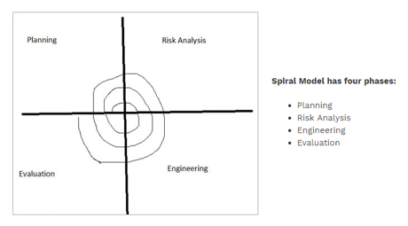

**Iterative Incremental model:**

* Divides product into small chunks
* The product increments in terms of features and once the iterations are completed the final build holds all the features of the product

**Phases of Iterative & Incremental Development Model:**

* Inception phase
* Elaboration Phase
* Construction Phase
* Transition Phase
* Advantages: any change in requirement is easily incorporated, risk is identified and analyzed, early detection of defects, iterations are easy to manage
* Disadvantage: need complete requirement and understanding of product to build incrementally

**Big Bang Model:**

* No defined process
* Input: money and efforts; output: developed product, which may or may not meet customer needs
* Developer performs requirement analysis, develops product per their understanding
* Suitable for small projects only
* Advantages: simple, minimal planning and scheduling, developer has flexibility
* Disadvantage: High risk and uncertainty

**Agile Model:**

* Combination of iterative and incremental models
* Focusses more on flexibility than on requirements
* Iterations are called sprints, typically lasting 2-4 weeks
* Each iteration incorporates a new feature, thus incrementally adding functionalities
* Customer feedback is taken for improvement and his suggestions and enhancement are worked on in the next sprint. Testing is done in each sprint to minimize the risk of any failures.
* Advantages: flexibility to adapt to changes, easy addition of features
* Disadvantages: lack of documentation, need of experienced, highly skilled resources

